 | contact  direct dial  email  our ref  your ref  date | Mr J Dean  01785 619209  jdean@staffordbc.gov.uk  30 July 2018

Dear Sir or Madam

Community Governance Review - Parish of Swynnerton

The Council has agreed to conduct a review of Swynnerton Parish, and as local residents or persons who may have an interest in the review I am writing to you for your opinion. This review is known as a Community Governance Review.

The review is being carried out in response to a petition handed to the council requesting that a new parish be formed to cover the Yarnfield parish ward. This would create two new parishes, one covering Yarnfield and one covering the remaining part of Swynnerton parish.

The enclosed documents provide further details for you to read about the review. Submissions can be made online at www.surveymonkey.co.uk/r/cgrSwynnerton2018 or by completing the attached response form. Every local government elector in your household is entitled to give a separate response. If you need further paper copies of the response form please contact us. Please note that anonymous responses will not be taken into account. The deadline for your comments to be included is 12 noon on Monday 10 September 2018.

Please contact my assistant Jim Dean on the above telephone number should you need any additional information.

Yours sincerely

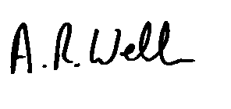
A R Welch LLB (Hons) Solicitor
Head of Law and Administration

