# Stafford Borough Council Logo

# Self-Build and Custom Housebuilding Register Application Form

Please fill in this form to register your interest in self-build and custom housebuilding opportunities in Stafford Borough. Please allow 15-20 minutes to complete this form.

Submitting this application form is simply an expression of interest that an individual or an association is looking to acquire a self-build plot within the Borough. The Council will then assess the demand and look to ensure sufficient plots are provided to meet the demand in the Borough as a whole, however, there is no duty to meet the needs of particular locations.

The information gathered will help us to find out more about the demand for self-build and custom housebuilding plots in Stafford Borough, including where people would like their plot to be and the type of dwelling that they would like to build. This will help us to inform the preparation of the Council’s future planning policies.

## Eligibility

Applicants must meet the basic eligibility criteria for entry onto the register, and the Council may contact you to confirm eligibility. By submitting this form, you are confirming that you (and where relevant, each member of your household or group) are:

* At least 18 years old;
* A British citizen, a national of the European Economic Area or of Switzerland;
* Seeking (either alone or with others) to acquire a serviced plot of land in Stafford Borough; and
* Are seeking to occupy this house as your sole or main residence.

An association is eligible for entry in the register if each member of the association meets all the eligibility requirements set out above.

If successful you will be added to the public register which is available to view on the Council’s Self Build and Custom Housebuilding webpage: [www.staffordbc.gov.uk/self-build-and-custom-housebuilding](http://www.staffordbc.gov.uk/self-build-and-custom-housebuilding)

**There are a number of questions where we require the information to be completed to allow for your submission to be entered into the register. These questions are marked with an asterisk *.**

**If you do not answer any of these questions you will be contacted to provide the relevant information.**

### How your submission will be used

The information you provide will only be used by Stafford Borough Council for the purposes of assessing the demand from individuals and associations for acquiring plots of land to build a home in Stafford Borough and to help inform the preparation of the Council’s future planning policies in accordance with the Self-build and Custom Housebuilding Act 2015 (as amended by the Housing and Planning Act 2016).

We will acknowledge receipt of your submission and may contact you for further information if required. We will not publish personal information such as your name, nationality, postal address, phone number and email address.

### Protecting Your Privacy

We believe you should always know what data we collect from you and how we use it, and that you should have meaningful control over both. As part of our ongoing commitment to transparency, and in relation to current data protection legislation, we have updated our Privacy Policy.

Stafford Borough Council are the data controller and you can find information about how we handle your personal data by visiting [www.staffordbc.gov.uk/self-build-register-submissions-how-we-use-your-personal-information](http://www.staffordbc.gov.uk/self-build-register-submissions-how-we-use-your-personal-information) and if you have any queries or would like to unsubscribe from receiving information then please contact [selfbuild@staffordbc.gov.uk](mailto:selfbuild@staffordbc.gov.uk).

## Personal Details

We require details from you in order to verify your eligibility and to contact you if required.

If you are registering as a couple, household or association, you should nominate a lead individual to provide their details as the primary contact.

### Your details (or details of the lead individual)

Name*:

Address (including postcode)*:

Nationality*:

Phone number:

Email address*:

Are you 18 or older?*  Yes  No

Are you making a submission on behalf of a couple, household, group or association? Do not count any members of your household under 18 years of age.*

Yes - as a couple or household comprised of two adults seeking a single plot of land

Yes - as a group, association or larger household seeking two or more plots of land

No - I am registering as an individual

Have you ever been entered onto the Stafford Borough Self Build and Custom Housebuilding Register previously?*

Yes

No

Don’t know

### Registering as a couple or household comprising two adults

We need details from your partner or the other member of your household to verify their eligibility.

**Other applicant’s details**

Name:

Address (including postcode):

Nationality:

Phone number:

Email address:

Is this applicant 18 or older?  Yes  No

### Registering as a group, association or larger household

We need details from all members of the group, association or larger household in order to verify their eligibility. If your group is larger than 5 members, please contact Stafford Borough Council directly to provide further details. The person entering their details in the earlier sections of the form is assumed to be the lead individual and primary contact.

Name of association (if applicable):

**Additional applicant 1’s details**

Name:

Address (including postcode):

Nationality:

Phone number:

Email address:

Is this applicant 18 or older?  Yes  No

### Additional applicant 2’s details

Name:

Address (including postcode):

Nationality:

Phone number:

Email address:

Is this applicant 18 or older?  Yes  No

### Additional applicant 3’s details

Name:

Address (including postcode):

Nationality:

Phone number:

Email address:

Is this applicant 18 or older?  Yes  No

### Additional applicant 4’s details

Name:

Address (including postcode):

Nationality:

Phone number:

Email address:

Is this applicant 18 or older?  Yes  No

Please tell us the total number of serviced plots the group is seeking to acquire:

## Area Preferences

This helps us to establish where demand for self and custom build may be most prevalent within the borough.

We will only accept applications to the register if you are looking for a plot within the boundary of Stafford Borough. Before submitting this application, please view the map below and check your preferred location (if known) is within the Borough boundary.

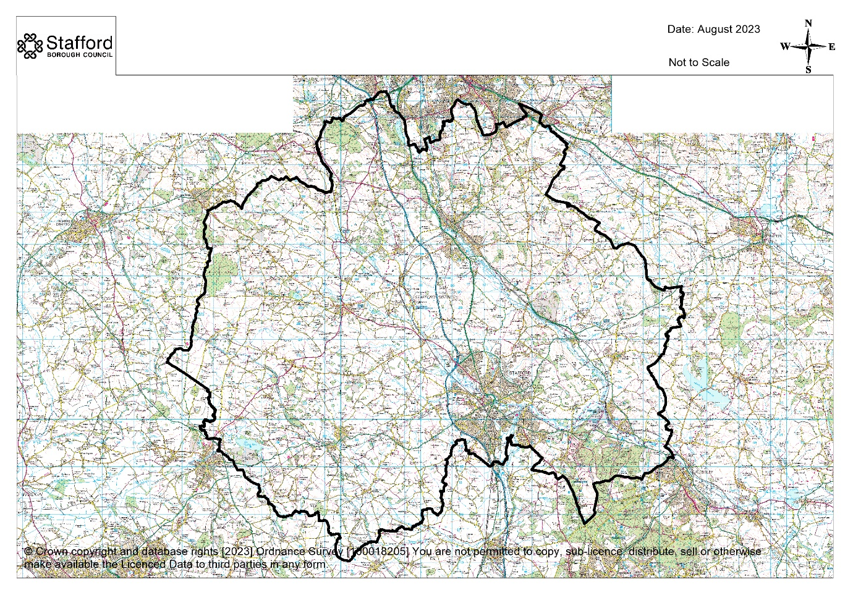

Do you have a preference for where you wish for your plot to be located?*

Yes, I have a specific area of Stafford Borough in mind

No, I have no location preference, other than within Stafford Borough

If you have answered yes to the above question, please state the nearest town or village? If you have multiple areas, please list them in order of preference.

What type of plot are you looking for? Tick all that apply

Rural

Edge of village / town

In village / town

No preference

Would you be interested in a serviced plot on a larger new housing development provided by a developer?

Yes

No

Unsure

Have you made a request to be included on the Self-build and Custom Housebuilding register in any other Local Authority areas? If yes, please tick the relevant authorities below.

Cannock Chase

East Staffordshire

Lichfield

Newcastle-under-Lyme

Shropshire

South Staffordshire

Staffordshire Moorlands

Stoke-on-Trent

Telford and Wrekin

Other, please state:

## Project interest and project specification

This helps us to establish your level of interest in undertaking a self or custom-build project and your housing requirements.

What is your current level of interest in self / custom build?

Very interested - I would definitely like to build my own home

Quite interested - I would consider doing it in future

Slightly interested - I would need further information

Unsure whether I could afford it or have the time to do it

Have you had previous experience of a self / custom-build project?

Yes

No

What is the main reason for wanting to build your own home? Tick all that apply.

Closer to family / personal / work links to area

More economic

Ability to secure a better quality of architectural design

Ability to stipulate higher build quality and specification

Eco-friendly design and materials

Ability to secure higher than industry standard energy efficiency

Sense of community

Individual / bespoke home to meet personal needs

Ability to specify location

Unable to buy a home

Other, please provide details:

What kind(s) of project are you interested in? Tick all that apply.

Self-build - you do all the work yourself

Supported self-build - somebody oversees some or all of the build, but you do most of the work yourself

Developer-led custom-build - a developer offers a serviced plot as part of a new housing development and a design / build service helps you customize the internal layout, fit-out and external finished of the dwelling to your own preferences

Self-finish - the weather-tight shell of the dwelling is already built by a developer, but you do all the interior works yourself

Community / collective build - a group of people design and build their own homes together

Supported community / collective build - a group of people are assisted by somebody who helps them design or build their own homes together

I am not sure yet

Other, please provide details:

What do you consider as the main barriers to self / custom housebuilding? Tick all that apply.

Plot / land availability

Financial constraints

Lack of experience / knowledge

Planning legislation

Other, please provide details:

What is the maximum amount you are anticipating spending on buying a plot?

I already own a plot

Up to £100,000

£100,000 to £150,000

£150,000 to £250,000

More than £250,000

What is the maximum amount you are anticipating spending on the entire build (including purchase of a plot)?

Up to £100,000

£100,000 to £250,000

£250,000 to £500,000

More than £500,000

If a suitable site was available, when could you (or your associate members) be ready to start? This is an estimate only.

Less than 1 year

1 to 2 years

3 to 5 years

More than 5 years

What is the minimum size of plot you would be looking for? *

Up to 0.05 hectares (0.05 hectares = 500m2)

0.05 to 0.2 hectares

0.2 to 0.5 hectares

0.5 to 1 hectare

Larger than 1 hectare

Unsure / don’t know at this stage

What type and size of home are you looking to build? *

Detached house

Semi-detached house or terraced house (as part of a larger scheme)

Bungalow

Apartment (as part of a larger scheme)

Other, please provide details:

Please provide the anticipated floor area of your build in m2:

How many bedrooms will you require? *

1

2

3

4 or more

What type of construction method are you anticipating using?

Traditional - Brick / bloc

Timber framed

Structural Insulated Panel (SIPS)

Prefabricated

Unsure / don’t know at this stage

Other, please provide details:

## Confirmation

Please tick to confirm that you (and / or each member of your household or group) are seeking to acquire a serviced plot of land in Stafford Borough to build a house to occupy as your sole or main residence*

I confirm that (and / or each member of my household or group) are seeking to acquire a serviced plot of land in Stafford Borough to occupy as my main residence

**Signature:**

**Date:**

The Strategic Planning team will contact you to confirm whether you submission has been successful or if further information is required.